AWS Cloud Quest  
**Task 9. File Systems in the Cloud**

Deploy and maintain a file system infrastructure that is accessible from multiple servers.

|  |  |
| --- | --- |
| Person | Hi there. Thanks for coming by to help us out. This is an important time for the city’s only per modeling agency. |
| Me | No problem. I am happy to help, and I love pets! |
| Person | Great! Let me explain. In the past year, we have established three new company branches in the city. Each branch has its own per image server that connects to a local client management application.  Each server stores images of all our pet clients along with informational metadata. We use a custom application to sync the client data across all three branches, but it takes too much time to access the images, and it’s not always consistent. |
| Me | I see. Is the storage capacity on each branch server the same? |
| Person | No. And that is another problem. Our syncing solution fails sometimes because one branch server might run out of storage space. We need a solution that centralizes our image storage and scales automatically. |
| Me | Okay, one more question. Does your team update the same files and also restrict certain files with permissions? |
| Person | Yes. All branches access and update the same pet client files, and we have certain folders for our VIP clients that only our concierge team has access to. |
| Me | Thanks! Based on your use case, I recommend Amazon Elastic File System, commonly called Amazon EFS, a serverless, set-and-forget solution that you can use to share file data without provisioning or managing storage.  Using Amazon EFS, you can create shared network drives so that your branches can access pet client photos from a central location, and you can restrict access with file-level permissions. |
| Person | That sounds good, but what about the storage capacity? |
| Me | Amazon EFS provides petabyte-scale storage that grows and shrinks automatically as you add and remove files. |
| Person | Nice! We want centralized storage, but what happens if Amazon EFS fails? Will we lose our client data? |
| Me | That is quite unlikely. Amazon EFS is highly available and is designed for 99.999999999 percent durability.  Also, by default, for file systems using standard storage classes, every EFS object is redundantly stored across multiple Availability Zones. Amazon EFS is even designed to sustain concurrent device failures by quickly detecting and repairing any lost redundancy. |
| Person | Wow, that's amazing! I think moving to Amazon EFS might work. Can you help us create an EFS file system in which all of our branches can access pet client photos from a single location?  Will you help us create an EFS file system? |
| Me | Accepted! |
| Person | Great! I will let you get to work. |

**Learning Objectives**

* Set up Amazon EFS.
* Create a mount target for the pet client photos repository.

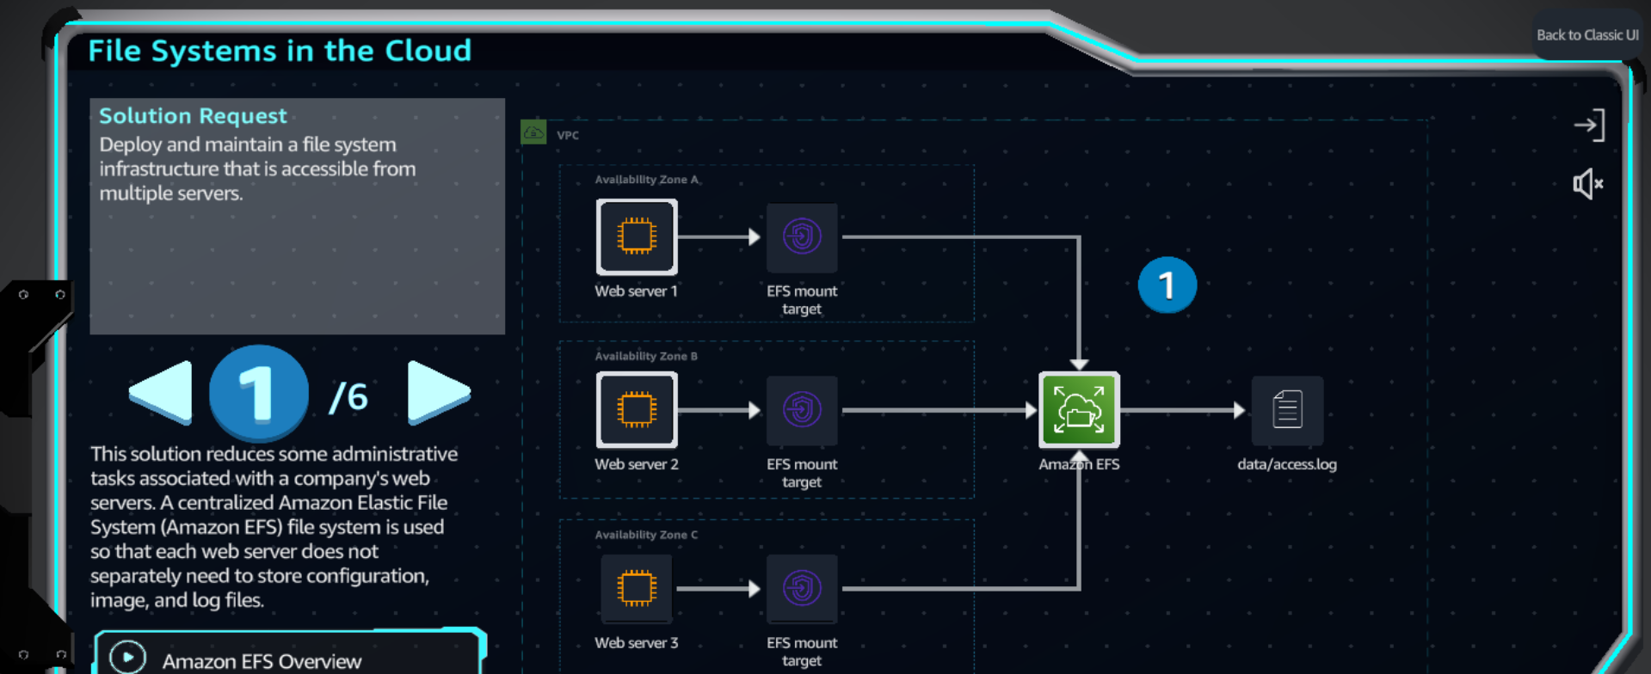

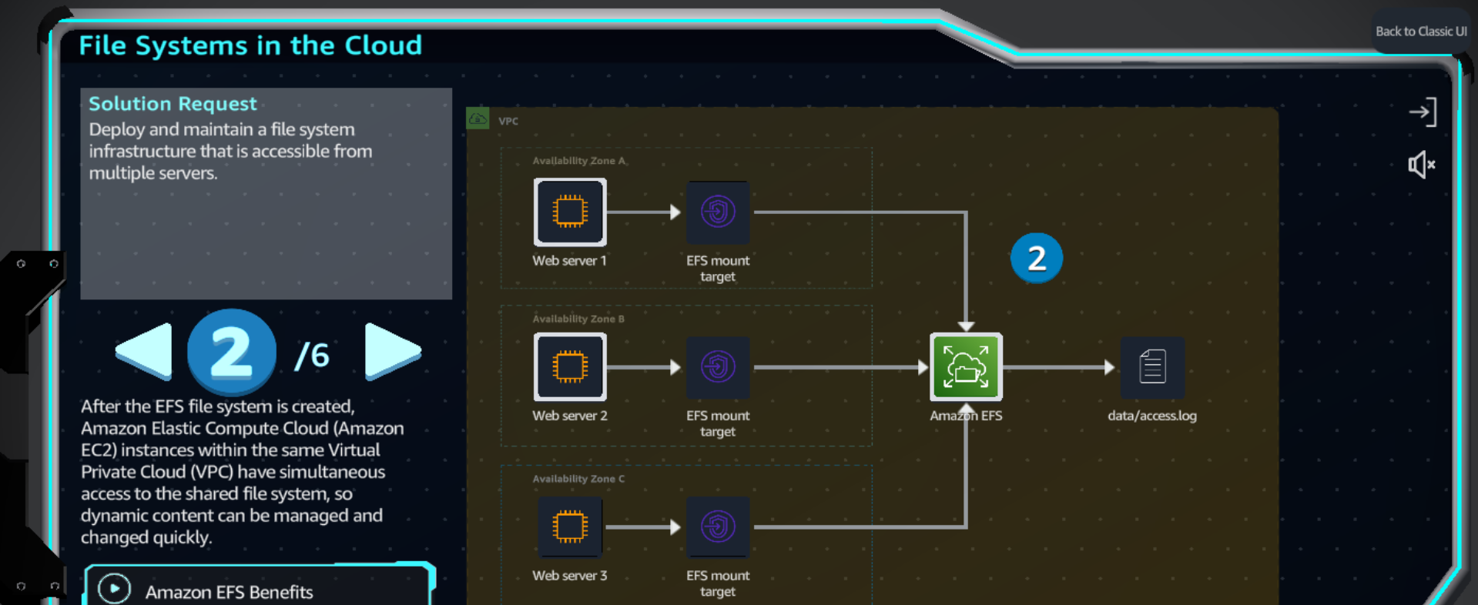

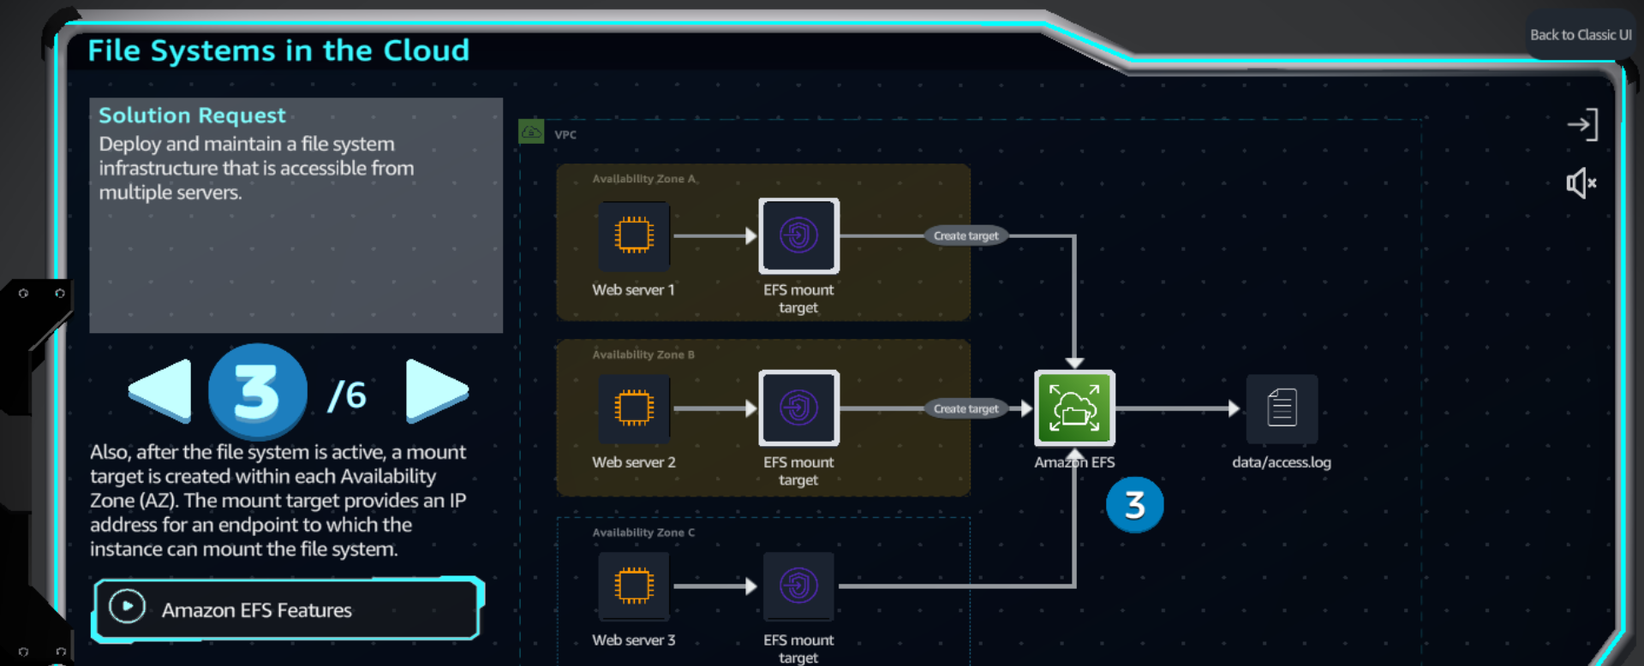

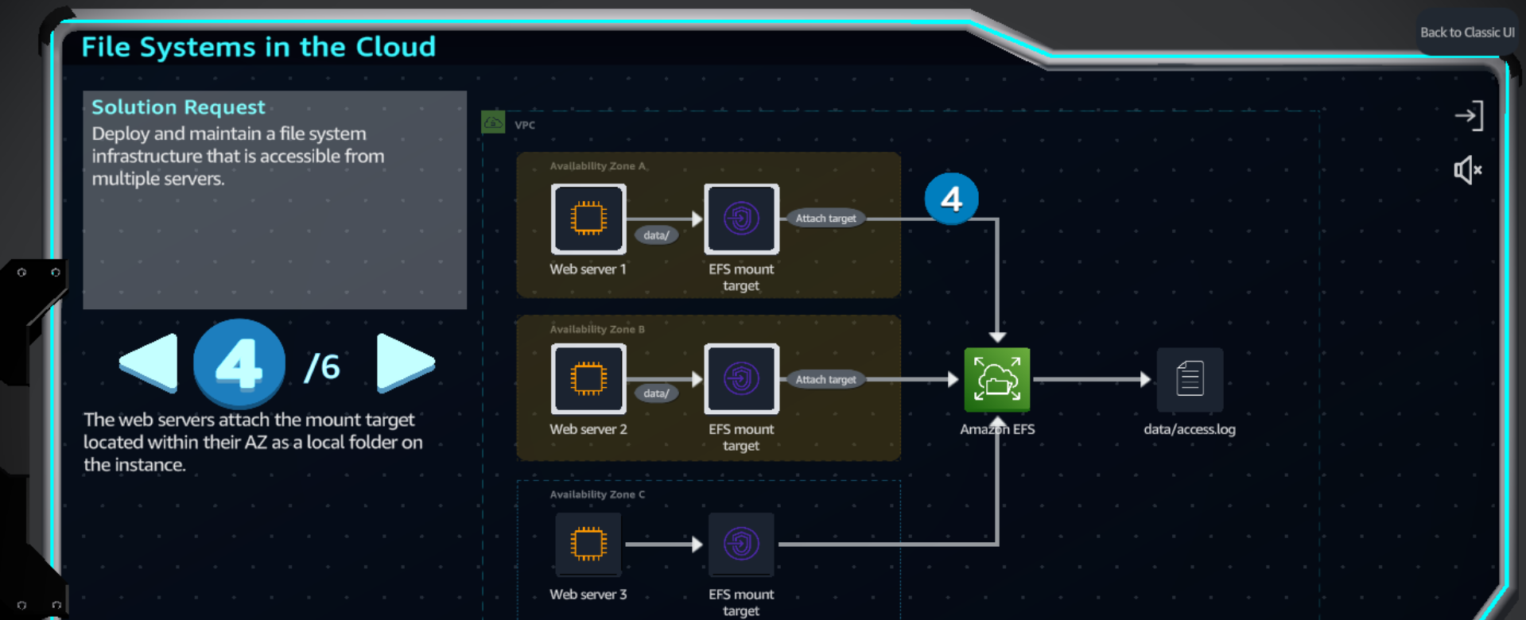

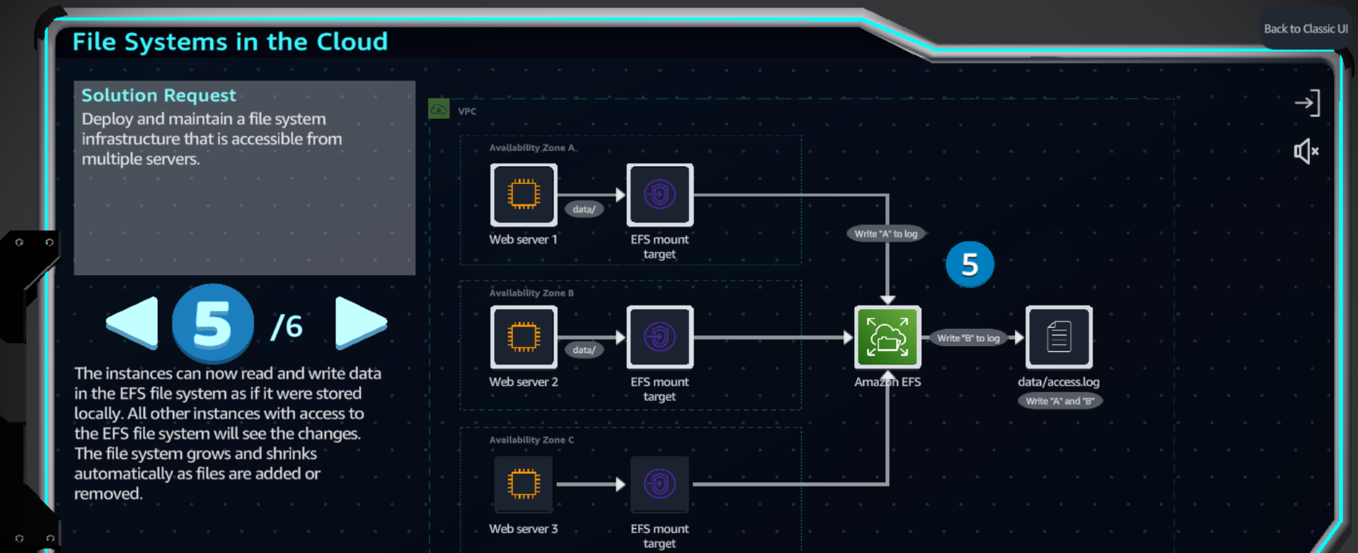

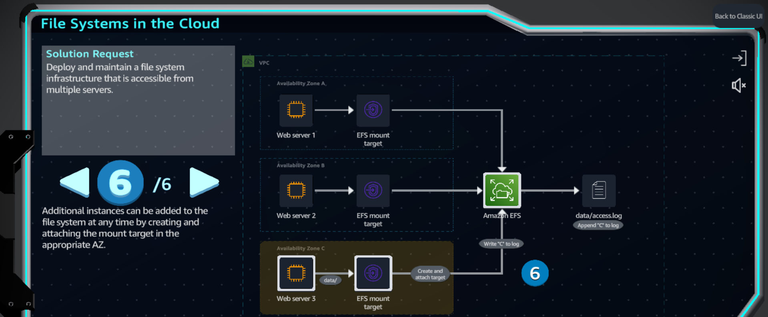

**Practice**

